**Deep Learning Project :**

MAIA Valentin, VUONG The Tai

**Introduction :**

Today we are in a world where we have access to a lot more data and a lot more computational power. Which enhanced significant improvements in application such as image recognition. For this project we are going to build from scratch a deep learning framework. The first part of this project is : building a two layers neural network, training it, then testing it on an example and finally applying it on handwritten digit classification. Moreover there are two additional exercises that are building a multilayer neural networks and then building a convolutional neural network. These two exercises are the ones that will be detail and fully explain through this report.

**Neural Network :**

For the first part that correspond to the quiz it is ask to summarize and tell what we understand about neural networks. First of all a neural network is composed of neurons that takes data as inputs and that outputs information. It can be either a classification or a regression method. A neuron is composed of two operations : a scalar product between the parameters and the input (+ the bias) and then a function that is applied to the result called activation that does not have parameters. If we want to outputs a vector instead of a scalar we need to build a fully connected layer which is a stack of neurons where each neuron output a scalar. When a neural network is composed of only one layer the model is linear. In order to make it non-linear we need to build a neural network with at least two layers (two layers for the first part of the project). In this case the first layer is called the hidden layer and the other one the output layer (in a multi-layer model of L layers, the L-1 first layers form the hidden layer and the last one form the output layer). The condition to get a non-linear model is to have an non-linear activation function in the hidden layer. Concerning the output it depends on the problem. In case of this project it is a classification task so we will use the softmax activation. The matrix outputted by the neural network is composed of N rows corresponding to the number of samples and of M columns corresponding to the number of classes representing the probabilities of the input belonging to the classes. In our work we implemented a step that one-hot encodes each one of these vectors with the value 1 being the argmax of the vector (the probability of belonging to the class that is the higher). The parameters that are going to be optimized during the training time are called the weights and the biases. Each layer has a matrix of weights and a vector of biases both depending of the number of neurons in the layer. Depending on the type of the problem the loss function that will be optimized thanks to gradient descent will be different. In a multiple regression problem the loss function is the Euclidian distance between the prediction and the real value whereas in a multi classification problem the cost function is the cross entropy. However these parameters will be optimized once the best hyper parameters are fixed. We can identify many hyper parameters as the number of layers, the number of neurons and activation function in each layer and many others. We have to be careful with setting these hyper parameters to avoid overfitting. However in the project we are not dealing with hyper parameters optimization as it will be an option for the user to fix them in the additional work.

**Exercise 11 : Multilayer neural network**

In this exercise we need to implement a multilayer neural network where the number of layers, the activation of each layer and the number of neurons of each layer need to be customizable.

**Dense_layer function :**

The first step is to modify our dense_layer() function in order to add more activation functions such as tanh, leaky ReLU, SELU and ELU.

-Tanh : The tanh function is an activation with the following formula

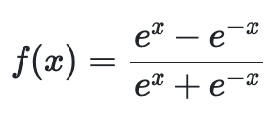

Which is basically what we compute : 

-Leaky relu is similar as relu function unless is does not fix negative values to zeros but to very small values. Thus it also a gave a value to the negative ones as well. As for relu the positive values remain unchanged.

- SELU is an activation that does a self-normalization that converge to zero mean and unit variance. In case of positive values we multiply it by a “scale” value that is fixed and in case of negative and zero values we take the exponential of the value minus one and then we multiply it by the “scale” value and an “alpha” value which is also fixed.



-ELU is an activation that does not modify the positive values. For negative values it does the exponential of it minus 1 and then multiply by a positive constant. In case of the constant = 1 we implement it as follow : 

All this functions are non-linear and separable activations.

We make sure our activations are correctly implemented : 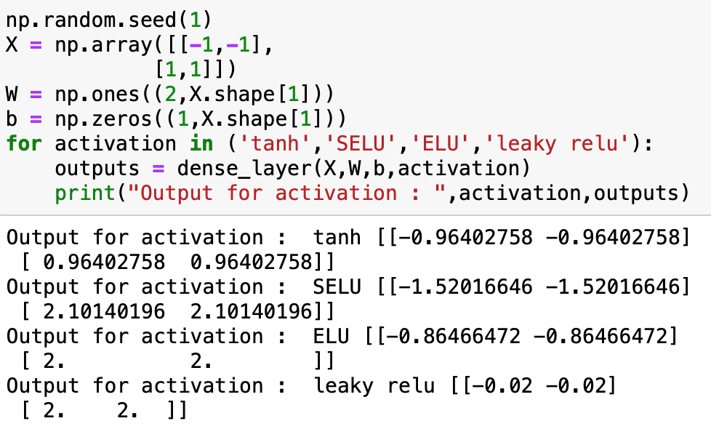

We can see that the behavior of each functions that we described above is respected.

**Initialize parameters function :**

The second step is to modify our initialize_parameters() function that was previously only initializing and returning the parameters for neural network model with two layers. We will do the same for a multilayer model. In this case we will have different parameters since the number of layers and the number of neurons in each of them need to be customizable.

Here is the new signature of the function : 

First of all the num_layers parameter represent the total number of layers which is the number of hidden layers + the output layer.

Then the n_hiddens parameter which is a vector will contain the number of neurons in each hidden layers. This induce that the length of this vector should be equal to the total number of layers minus the output layer.



We don’t have to precise the number of neurons in the output layer since it’s not customizable. Indeed the number of neurons in the output layer is problem dependent, in our case in a multi classification problem the number of neurons in the output layer is equal to the number of class.

We create an array that will contain all the parameters : the weights and the biases

Now for the next step in the function which is to get the different values of rows and columns to initialize the weights matrices we need to be careful. The layers are in cascade, it mean that the output of a layer is going to be the input of the layer that follow.

We also know that the weight’s matrices of each layers have a special size that depend on the size of what we input to the layer (output of the previous layer except for the first one which is the input of the model) and on the number of the neurons in the layer. Each weight’s matrice has a number of columns equal to the number of neurons in the layer and a number of rows equal to the number of features of what we input in the layer (number of columns of the input). Finally the biases of each layer are vector matrices with a number of columns equal to the number of the neurons in the layer. Here is the translation of what we just explained :

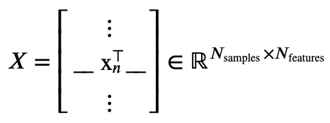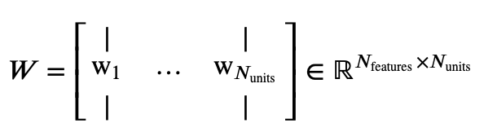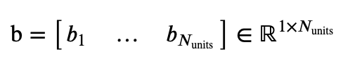

Where Nunits is the number of neurons in the layer.

Here is the implementation of what we just explained in this step. We did not modified how were the weights randomly initialized

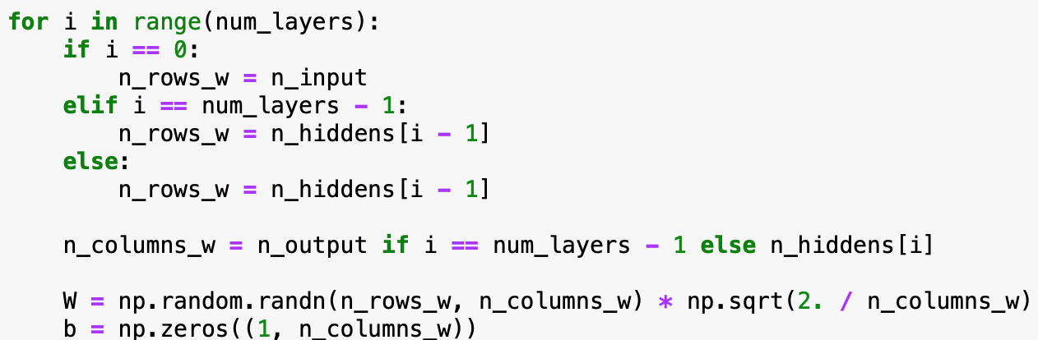

As an example we can see how the weight’s matrice of the output layer is initialized with a number of columns equals to n_output which is the number of class as we explained above.

We make sure our function is working as we want :

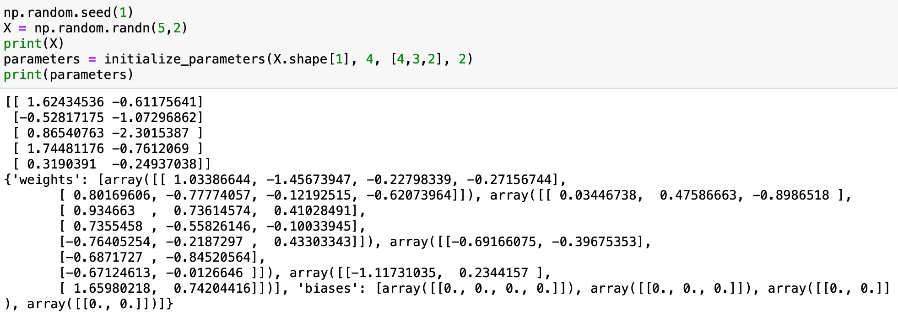

First of all we take the number of columns of the input as our first parameter which correspond to what we said since the number of rows for the first weight matrice needs to be equal to the number of features which is the number of columns of the input.

In our example we want a model with 4 layers, 4, 3, 2 as the number of neurons in each hidden layer and 2 classes. It is well respected as we can see for the first weight matrice the number of columns is equal to the number of neurons and the number of rows equals to the number of features of the input. As well as the last one that has 2 columns corresponding to the 2 classes.

**Dropout function :**

The third step is to implement a dropout function. Which is done in order to avoid overfitting. The dropout function will randomly set to zero some nodes of the neural network during one iteration of the gradient descent during the training. The only two parameters of the function are the input on which we will apply the dropout and the probability to keep a node.



As it is explain on the lecture we apply a mask to the inputs that will keep only some nodes. We also divide by the dropout probability in order to scale the values so we maintain a consistent behavior between training and testing. 

We make sure that the function is working as we want :

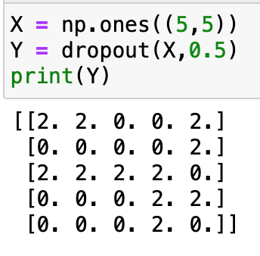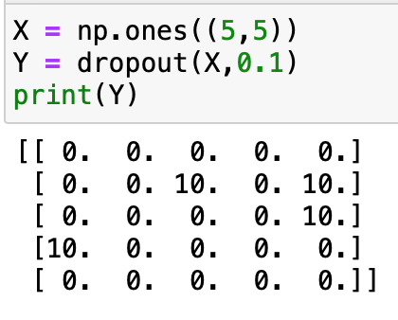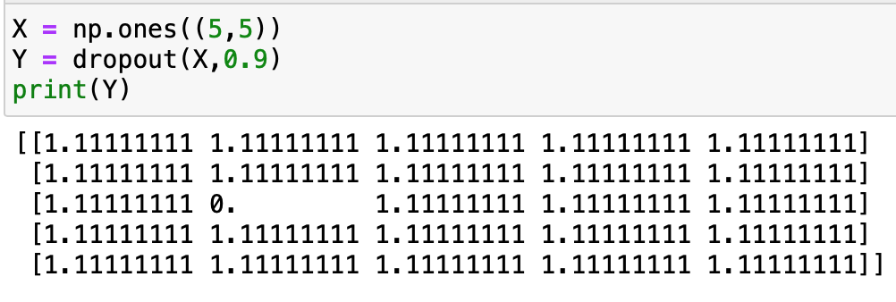

As we can see the function is effectively working, the closer to zero the probability is the less values we keep and the closer to one the probability is the more values we keep.

To implement it we also need to modify the dense layer function we created by adding a dropout_prob parameter and a condition when we want to implement it :

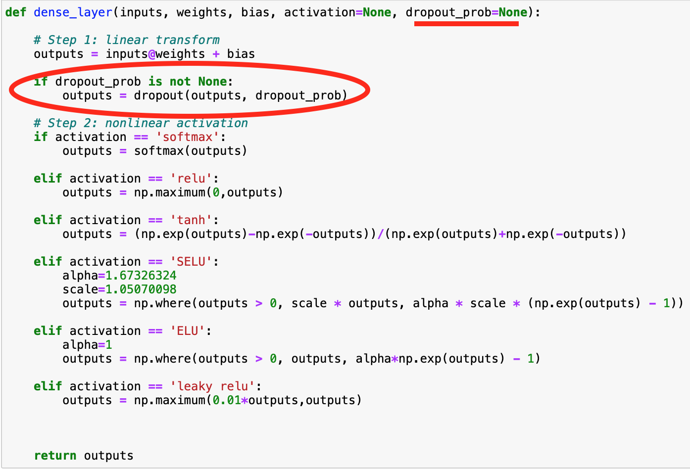

**Multilayer_network function :**

The fourth step is to create the multilayer network function that will compute the output of the neural network. In order to achieve this goal the function will need to take some parameters. The first one this the input of the problem, the second one is the parameters the third one the different activations functions and finally the last one a possible dropout_prob.



We know that there is as many weight’s (or bias) matrices as the number of layer. We will then go through the length of the number of weight’s matrices and compute the two operations of the neural network done by the dense layer function that we already created. 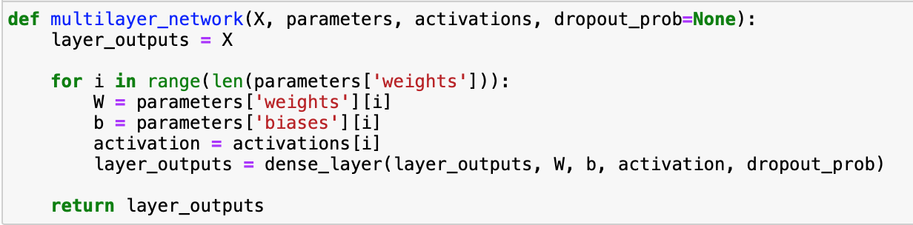

We can try to use this function with an example :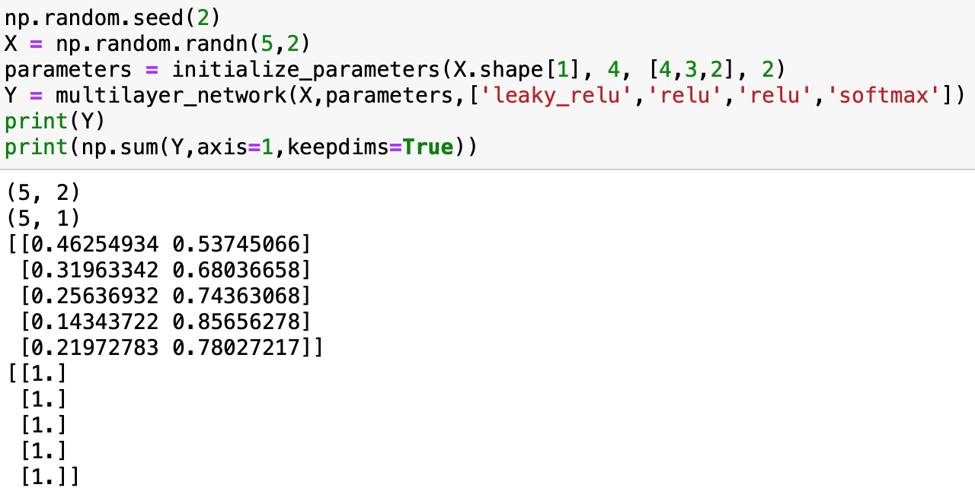

We parameters are initialized the same way we did before. Concerning the multilayer_network the only obligation we have is to use the softmax function as the activation of the output layer as we simulate in this example a multi classification problem. In this case each columns represents the probabilities to belong to the class 1 or 2. Normally if we compute the sum along the rows we should get only ones. It’s exactly what’s obtained.

**StochasticOptimizationProblem class and stochastic_training function :**

Concerning the StochasticOptimizationProblem class we only need to make a small change compare to the one already implemented for the quiz. The change is concerning the way we run the network on the batch.

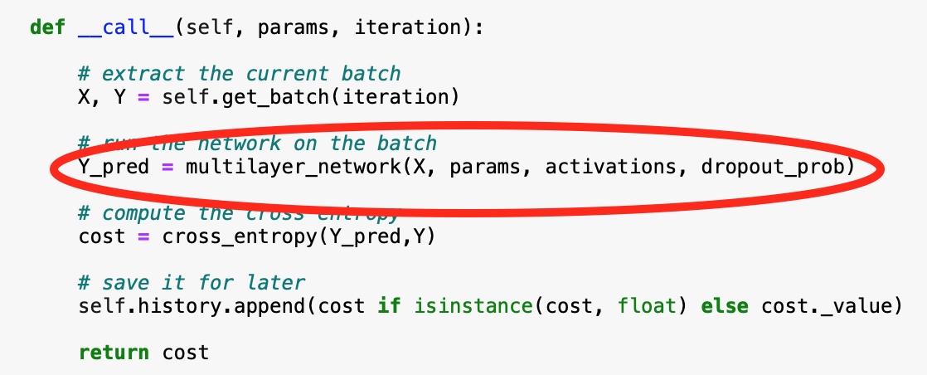

We need to use the multilayer function instead of the two layer function.

For the stochastic_training function we also need to make some changes compare to the one previously used for the two layer network. 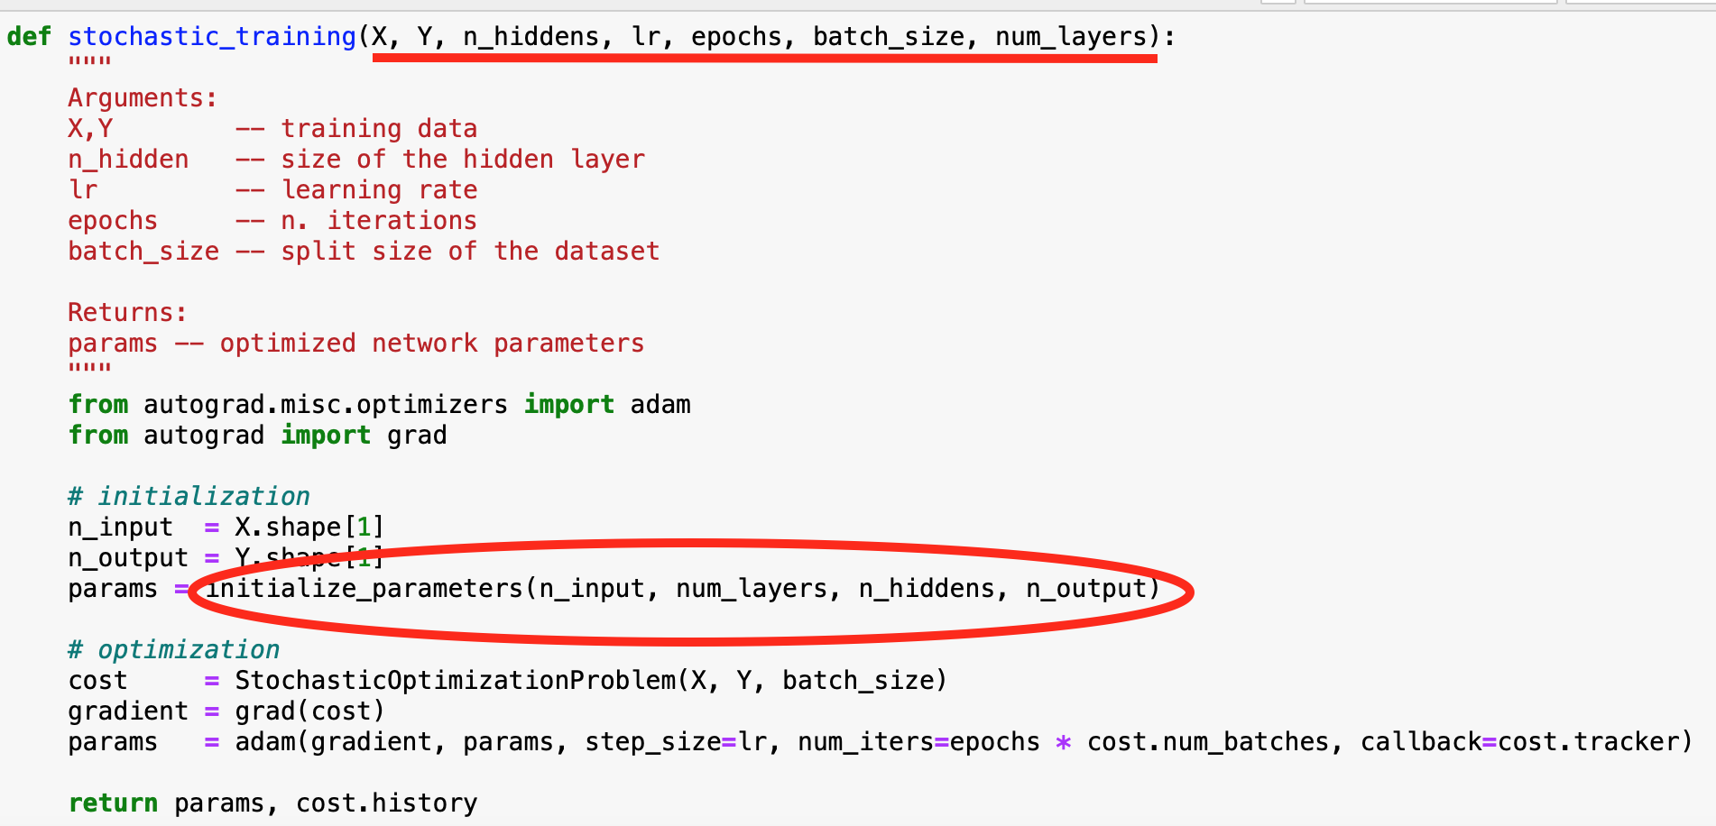

We need to add a num_layers parameter since it’s now something that we can customize. Moreover even if we still have the n_hiddens parameter it does not is the same since now it’s a vector with the number of neuros in each layer. The initialize parameters function is also modified as we now use the one we just implemented. We are now ready to test our model.

**Implementation of the multilayer neural network :**

For the implementation we will use MNIST dataset and use what have been done about the images (reshaping, scaling and categorically encodes the labels) during the ‘*Handwritten digit classification’* part of the notebook.

First thing to do is the training part, where we will define the different activations, the number of layers , the number of neurons. At first we will not add the option of having dropout.

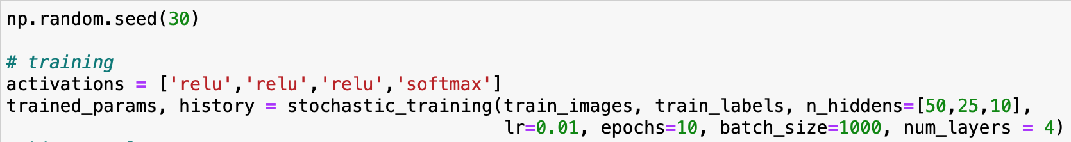

For our first implementation we decided to have 4 layers , relu activation for the hidden layers and softmax activation for the output layer (we do not have the choice concerning the softmax activation) with 50, 25 and 10 neurons for each hidden layer.

We can see with the History plot that the cross entropy is indeed decreasing and converging to small values close to 0 which is something we want. 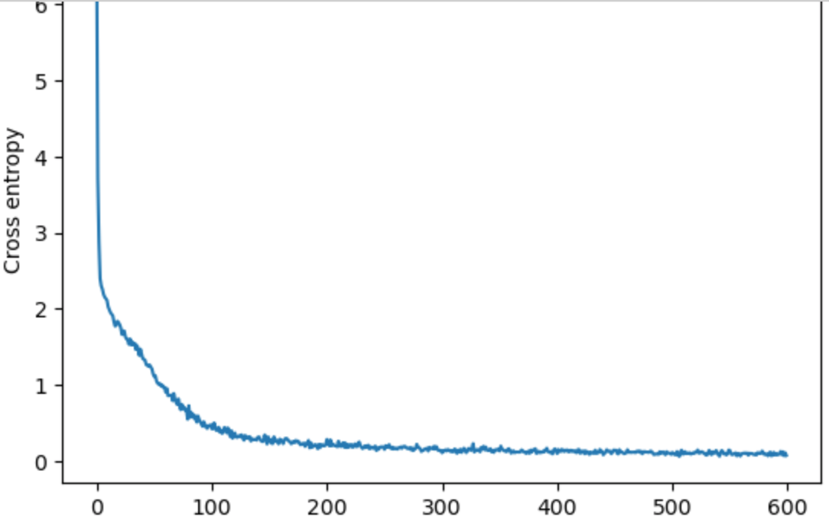

We can now fit our model with the optimized parameters on the test images

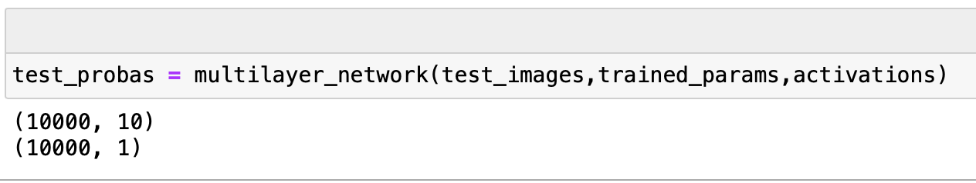

There are 10 columns corresponding to the 10 classes (digits from 0 to 9) for which there is the probability to belong to each of them.

Finally to get the prediction we just take the column with the highest value which is the class with the highest probability for each row.

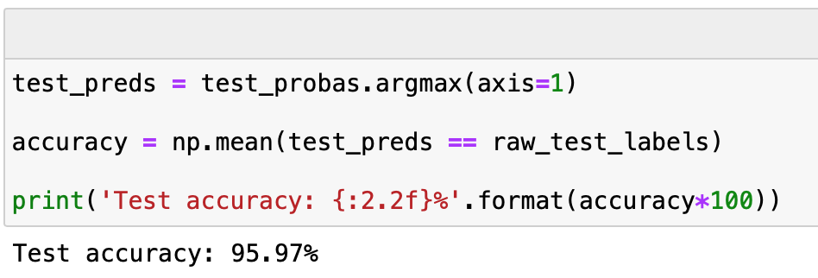

With our choices concerning the model we got a Test accuracy of 95.97% which is impressive. Furthermore we can see that there is no overfitting. This is enhanced by the data preprocessing that has been done where the inputs have been normalized but also thanks to the ADAM algorithm. This is also due do the choice of the parameters (number of layers, neurons) that make the model not too complex.

Here are some other models with different choices of activations functions :

SELU :

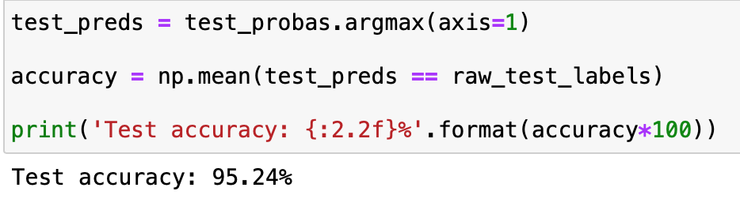

ELU :

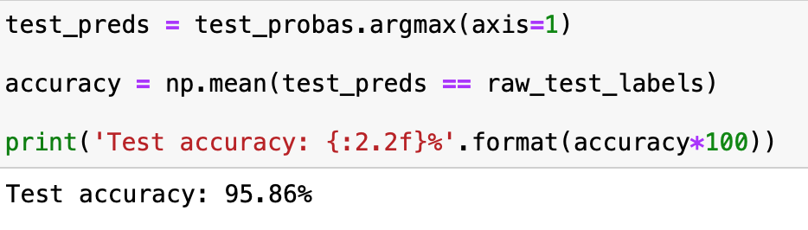

tanh :

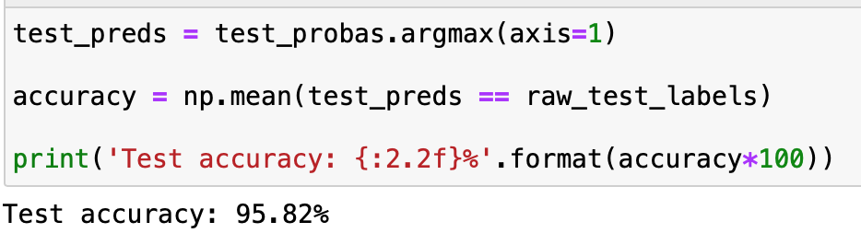

leaky relu :

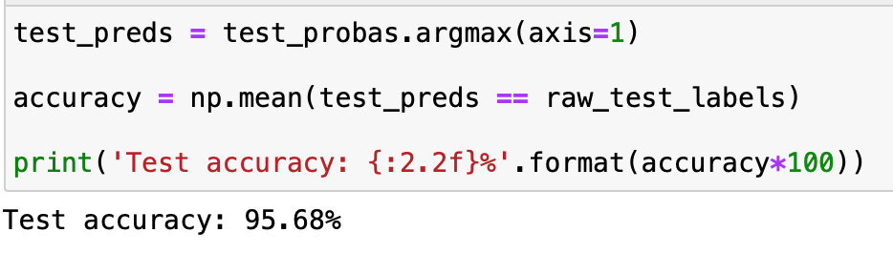

We can see that the best test accuracy is obtained with a relu activation but the score is quite the same for every activation.

We now decide to add some dropout to see how our model react to it and if we can reach an even better accuracy. We decide to have a dropout_prob of 0.9 for the first implementation :

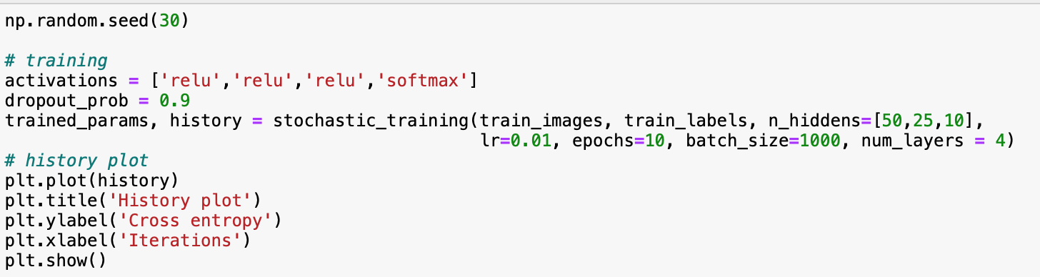

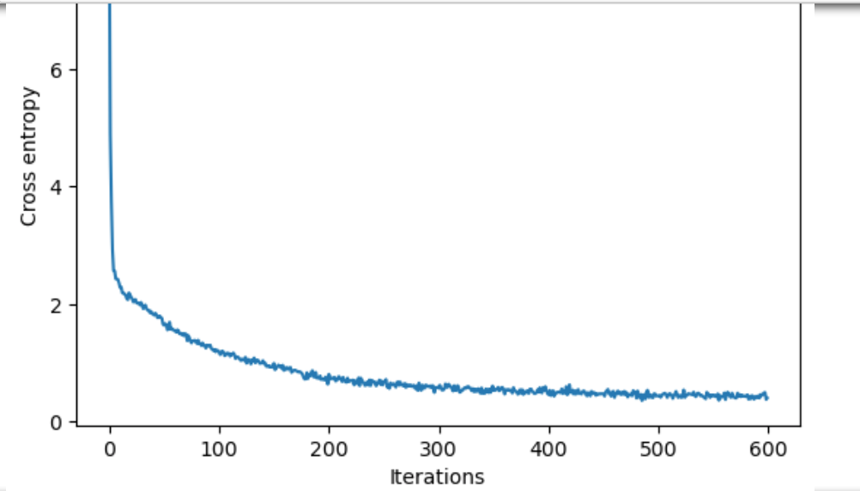

The cross entropy is indeed still converging to 0.

We reach an accuracy of 94.83% which is a bit less than we achieved without dropout but it’s still very satisfying.

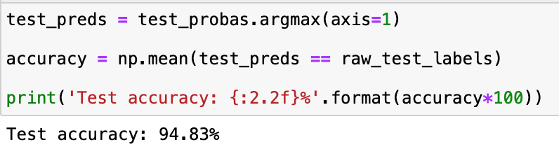

We still want to try to achieve a better accuracy with dropout. We decide to now increase the number of neurons in the hidden layers :

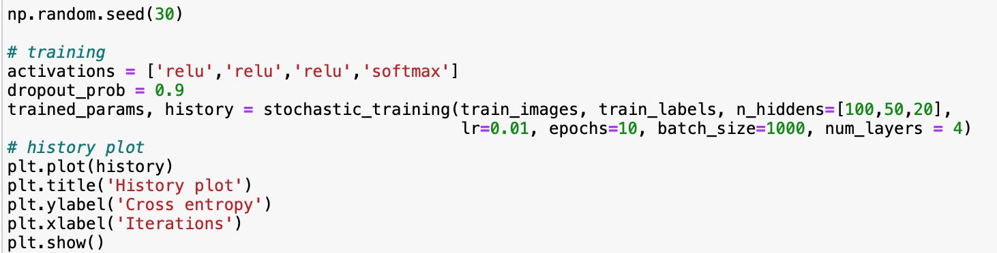

And indeed by having more neurons and then more nodes the dropout implementation enable us to reach a better accuracy :

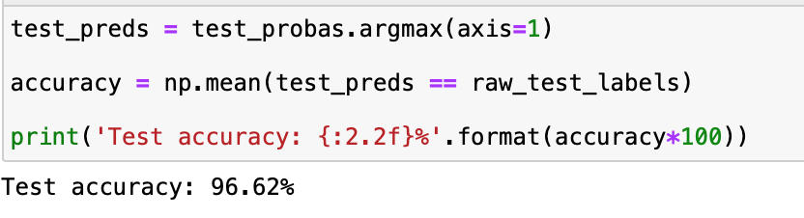

**Digit Images :**

As a final step we will process our multilayer neural network on a list of digit images. In order to do this we will reuse the digit recognition function that was done previously by adapting it to a multilayer model.

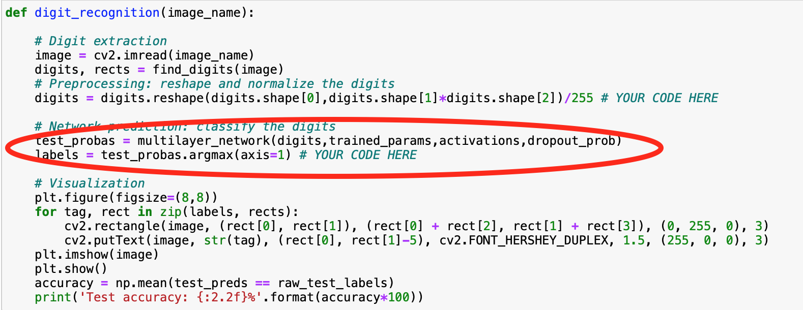

Here we are using the multilayer network function.

Finally we can see the prediction of our model on real handwritten digits :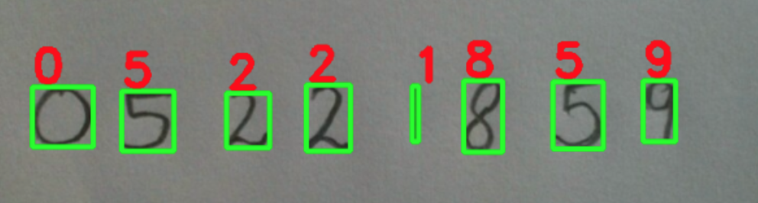

We can conclude and see how well accurate our model is.

**Exercise 12 : “LeNet-5” convolutional neural network**

In this exercise we will build a convolutional neural network. This type of networks are built for image related tasks. Since high resolution images are high dimensional and hence have too many parameters for standards networks. Implementing convolutional neural network will highly reduce the number of parameters. Convolutional neural networks can be divided in two parts the first one is called the feature extractor and is a succession of convolutional and pooling layers, the second part is called the classifier and composed of a flatten layer with some fully connected layers.

**Convolutional layer function :**

Here we create the function that will do the convolution between the input and the filters (or kernels). We know that the convolution has a limit defined by the size of the filers. At each convolution we are moving the filter to a different chunk of the input. The output of the convolution are our new parameters that need to be learned.

Here we are just applying what is indicated to us :

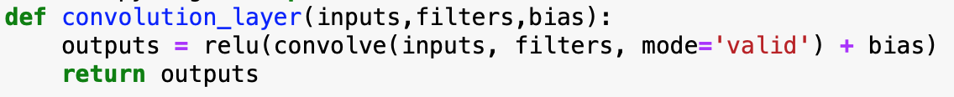

By looking at the description of the function we saw that mode=’valid’ will give us the correct shape for the output that we saw in the lecture. For example a 2D input with a (W,F) shape and a filter with a (w,f) shape will give an output with a (W-w+1,F-f+1) shape.

We just also need to defined the relu function that will do the same from what the activation was already doing here we just create the function : 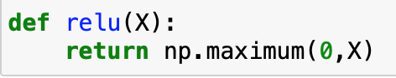

And finally we implement a small example to check if it’s correctly working : 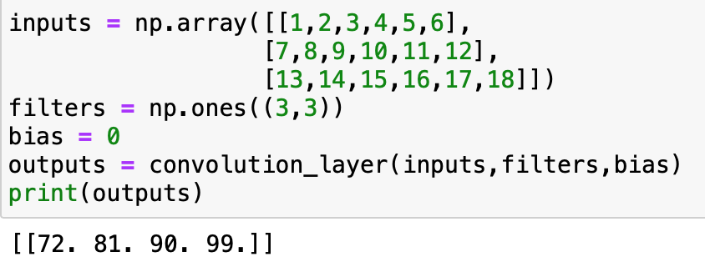

We can see that this is effectively working because :

1x1 + 1x2 + 1x3 + 1x7 + 1x8 + 1x9 + 1x13 + 1x14 + 1x15 = 72

1x2 + 1x3 + 1x4 + 1x8 + 1x9 + 1x10 + 1x14 + 1x15 + 1x16 = 81

1x3 + 1x4 + 1x5 + 1x9 + 1x10 + 1x11 + 1x15 + 1x16 + 1x17 = 90

1x4 + 1x5 + 1x6 + 1x10 + 1x11 + 1x12 + 1x16 + 1x17 + 1x18 = 99

However for 4D matrices like the images on which we want to train the model this convolution’s function is not working. That’s why by looking at the documentation and the example provided by Autograd we modified the function :

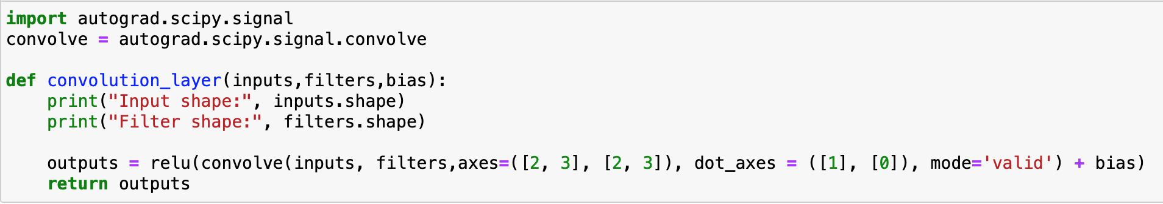

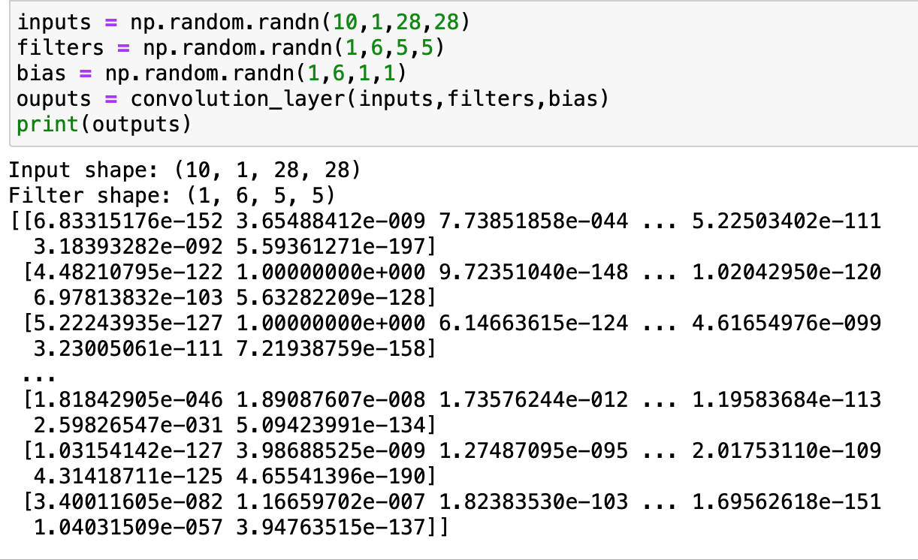

**Pooling layer function :**

We will now create the pooling layer function that will reduce the spatial size of the input. Moreover it will not modify the number of channels but reduce the size from each of them. Since this layer will just modify the size there are no parameters to be learned. In our case it will divide by two the number of rows and columns from each channel.

Now we simply implement the function based on the example given for a 2D array by adapting it for a 4D array:

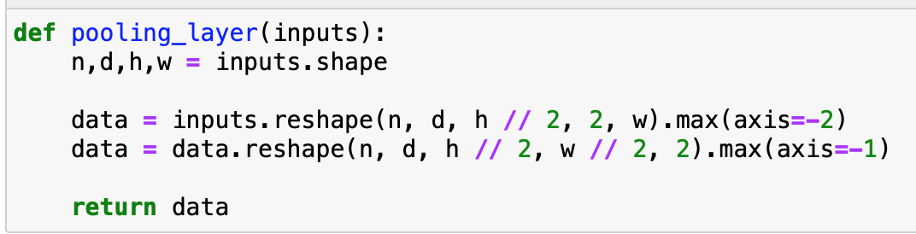

We do an example with a 4D array

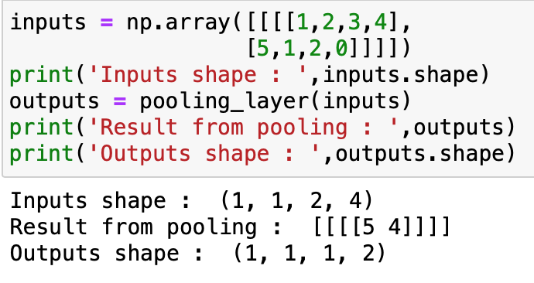

We can see that this is correct since max(1,2,5,1) = 5 and max(3,4,2,0) = 4.

Moreover the dimensions are as we want.

**Flatten layer function :**

We are now going to implement the flatten layer function that belongs to the classifier part of the convolutional neural network. This is the layer that is just before the fully connected layer and that transforms a 4D array into a 2D array.

Here is the implementation with an example :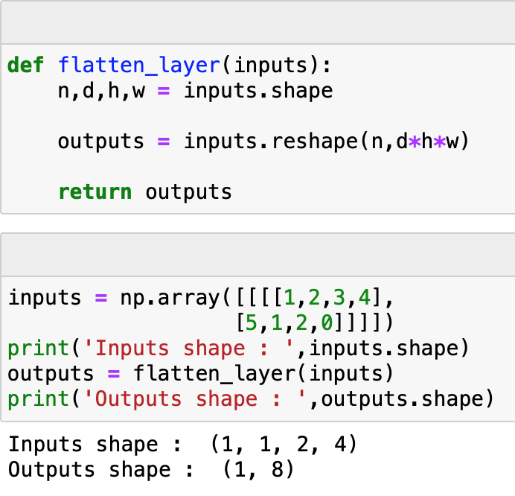

We indeed reshaped the inputs into a 2D array.

**Initialize parameter function :**

It’s now the tricky part of the creation of the model. We will need to return the different parameters of the “LeNet-5” convolutional neural network. The “LeNet-5” model has his proper architecture and here is the representation of it as we saw in the course : 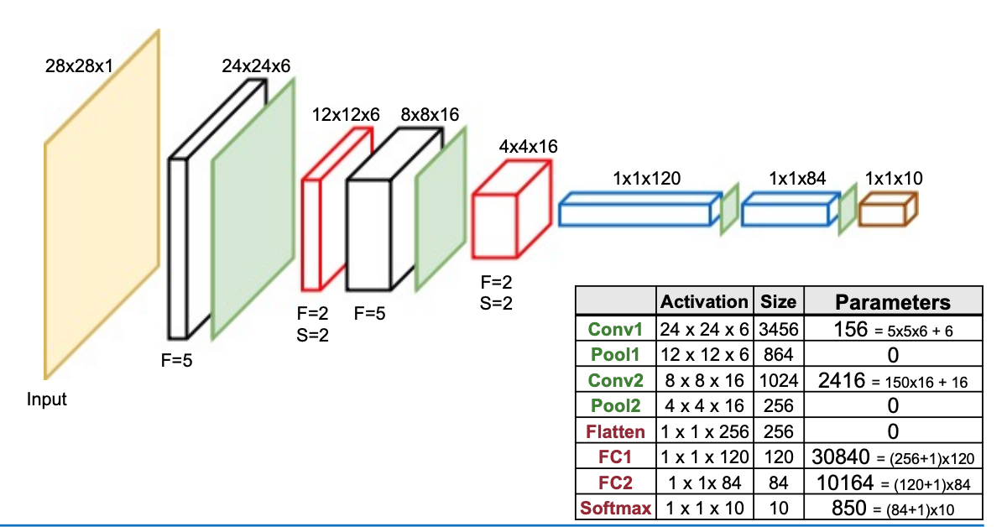

It’s composed of :

-2 convolutional layers

-2 polling layers

-1 flatten layer

-2 fully connected layers

-1 softmax layer

Moreover we can see that we know the number of parameters in advance for images with 28x28x1 shape which are the size of MNIST dataset images. As we already said the pooling and flatten layers do not have any parameters. That’s why in our initialize parameter function we will define the parameters only for the two convolutional layers and the two fully connected layers. The sizes of the weights and biases parameters for the convolutional layers are already know and given :

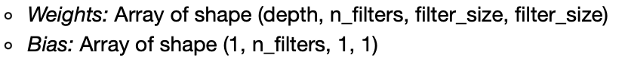

However we still need to know the shapes of the filters used. Based on the representation of the “LeNet-5” that we got just above we are able to determine them.

For the first convolutional layer :

The input has a 28x28x1 shape and the output a 24x24x6 shape.

Moreover here is the general shape of a filter FxFxCxK with F the spatial size of each kernel, C the kernel depth and K the number of kernels. The kernel depth is equal to the number of input channels and the third dimension of the output is equal to the number of kernels. Finally as we said before for example a 2D input with a (W,F) shape and a filter with a (w,f) shape will give an output with a (W-w+1,F-f+1) shape. Knowing this we now can determine the shape of our first filter :

Concerning the spatial size FxF we know that : 28 – F + 1 = 24 => F = 5

The number of kernels is equal to the third dimension of the output so K = 6

The kernel depth is equal to the number of input channels so C = 1

Our first filter has the a 5x5x1x6 shape. Moreover we can verify the number of parameters to be learned with the following formula :

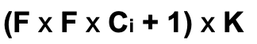

With p the number of parameters p = (5x5x1x6) + 6 = 156 which is the value we expect as we can see above.

The shape of the first Weights and bias arrays are then :

**1x6x5x5 for the Weights**

**1x6x1x1 for the bias**

For the second convolutional layer :

The input has a 12x12x6 shape and the output a 8x8x16 shape.

Concerning the spatial size FxF we know that : 12 – F + 1 = 8 => F = 5

The number of kernels is equal to the third dimension of the output so K = 16

The kernel depth is equal to the number of input channels so C = 6

With p the number of parameters p = (5x5x6x16) + 16 = 2416 which is also the value we expect as we can see above.

The shape of the second Weights and bias arrays are then :

**6x16x5x5 for the Weights**

**1x16x1x1 for the bias**

For the first fully connected layer :

Concerning the fully connected layer we already saw in the multilayer neural network that the number of rows of the Weight’s matrice is equal to the input dimension and the number of columns to n_hidden which was the number of neurons. With the bias being a matrice vector with the number of columns equal to the number of neurons.

It means that in our “LeNet-5” architecture we know that the first fully connected layer follow the flatten layer that has a 1x1x256 shape and the number of neurons for the fully connected layer is 120. Hence the Weight and bias matrices have the following shapes :

**256x120 for the Weights**

**1x120 for the bias**

We can verify the number of parameters for this layer with the following formula :

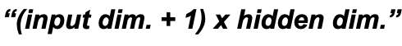

With p the number of parameters p = 1x1x256x120 + 120 = 30840 which is the correct number of parameters expected for this layer.

For the second fully connected layer :

Concerning the second fully connected layer the input will have a shape 1x1x120 since it follow the first fully connected layer. Moreover the number of neurons in this second layer is equal to 84. Hence the Weight and bias matrices have the following shapes :

**120x84 for the Weights**

**1x84 for the bias**

We also check the number of parameters p = 1x1x120x84 + 84 = 10164

For the output layer :

We calculated the parameters for the hidden layers now we also need to do it for the output layer. We know that the shape of the Weights matrice has a particular number of columns which need to be equal to the number of classes. In our digit recognition problem this number is 10 (reminder : the number between 0 and 9). Concerning the number of rows and the shape of the bias matrice it’s the same as we explained for the hidden layers then the Weight and bias matrices have the following shapes :

**84x10 for the Weights**

**1x10 for the bias**

We can now implement the function with the shapes we calculated :

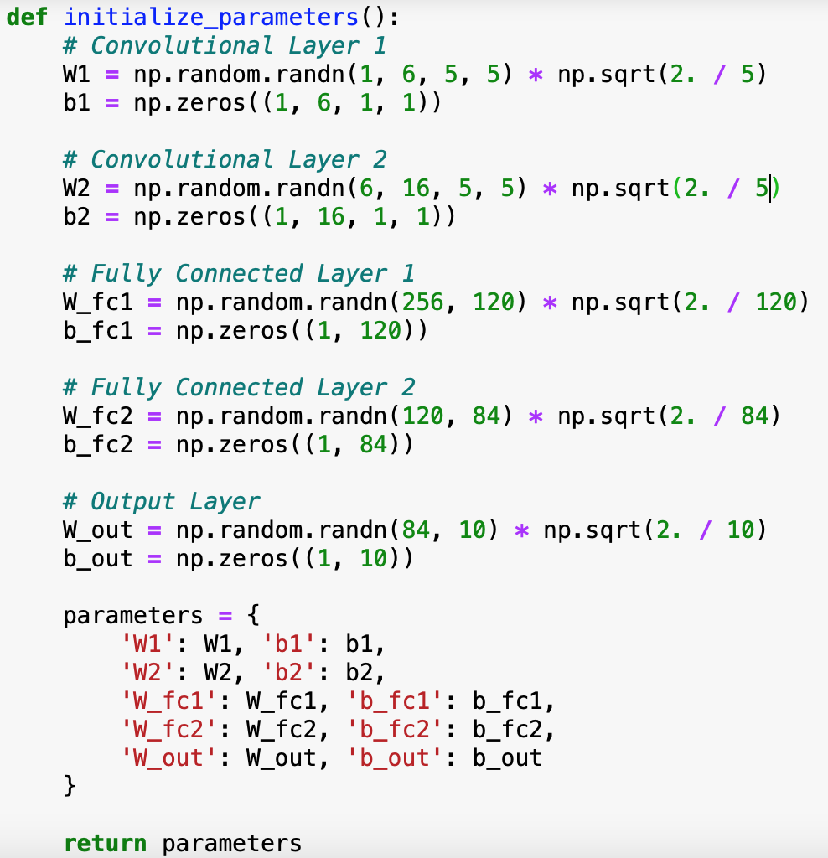

We check that the function is correctly working :

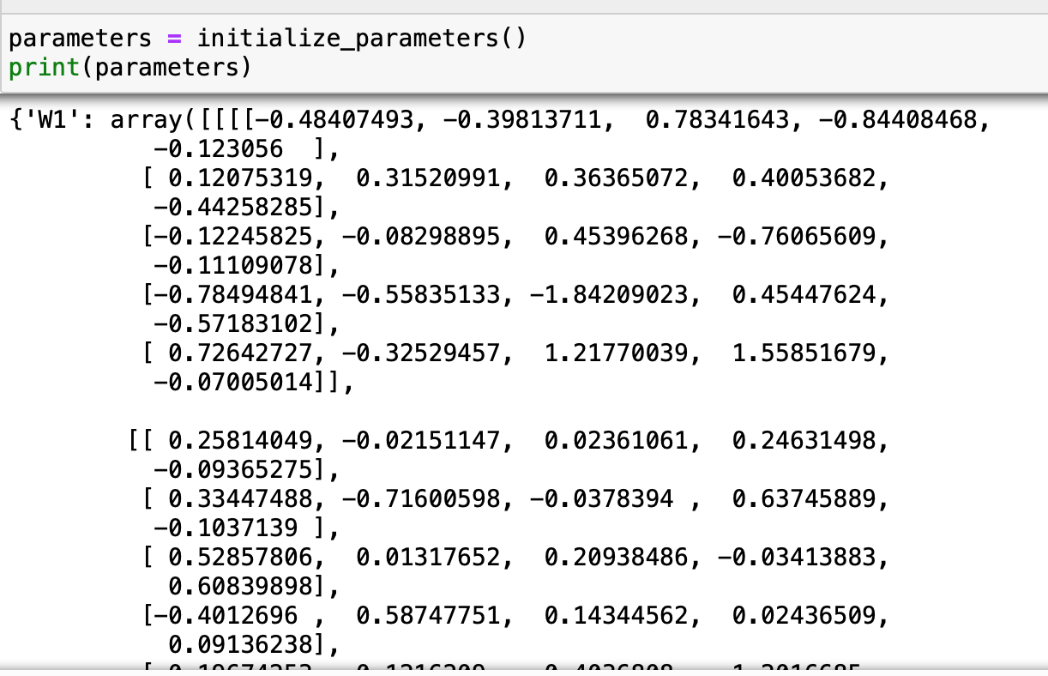

**Convolutional network function:**

We now need to define this function to compute the output of le LeNet-5 network. We implement the different layers that we previously saw in the good order :

Convolution Layer/Pooling Layer/Convolution Layer/Pooling Layer/Flatten Layer/Fully Connected Layer/Fully Connected Layer/Output Layer

We need to be careful with the different parameters for each function. But first of all the signature of the function :



It will take the inputs, the parameters that we initialized (the weights and biases) and the activations that are the activation functions for the two fully connected layers and the output layer.

Then we retrieve the parameters so we can put them correctly in each layer :

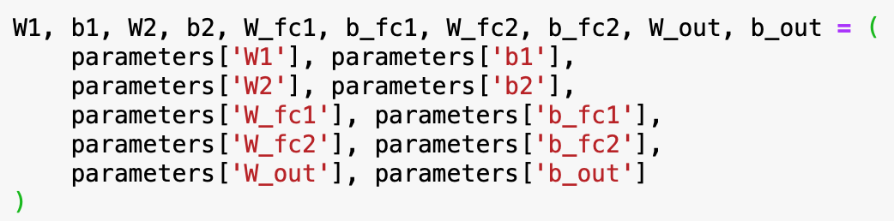

Finally we call the different functions we created in the right order : 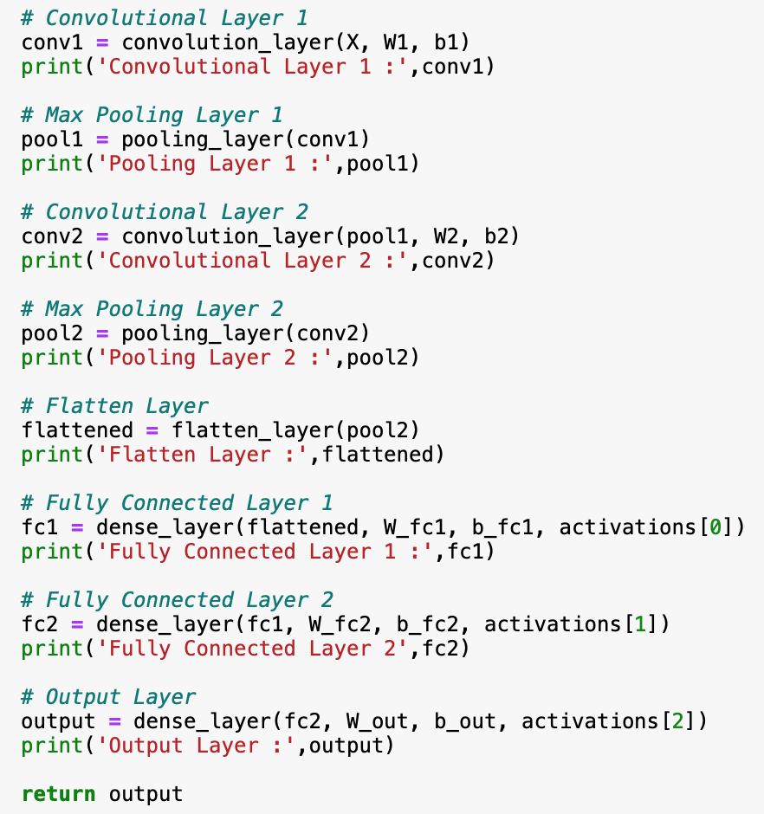

With the output being the probability to belong to the classes and this for each rows.

**StochasticOptimizationProblem class and stochastic_training function :**

Concerning this section as we did for the multilayer network only small changes are needed to adapt it for our model :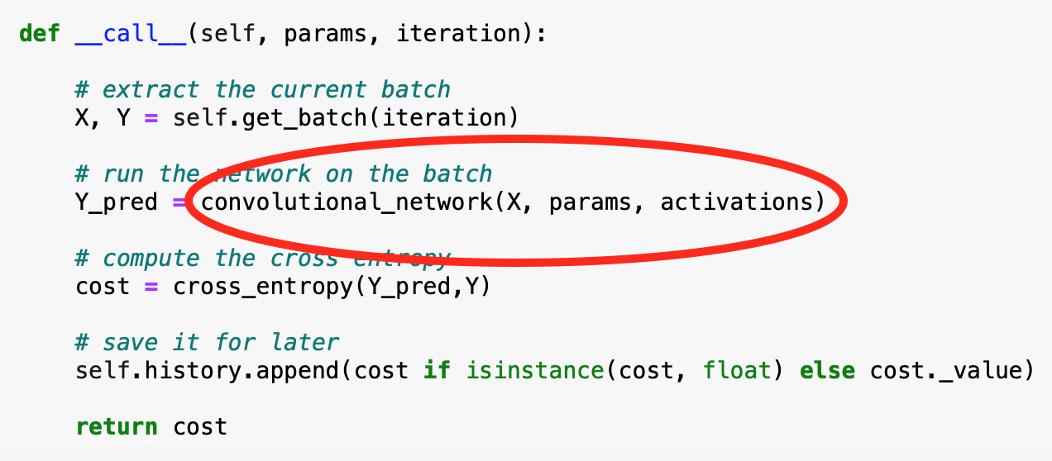

For the stochastic training function we now have less parameters :

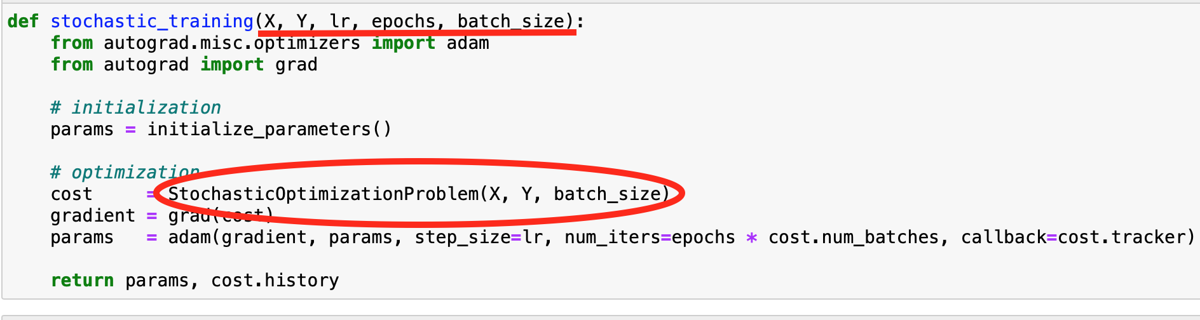

**Implementation of the convolutional neural network :**

We are now ready to implement the model. We are also going to use the MNIST dataset however we will have to reshape the images in the correct format for our model. Moreover we normalize the data to make the training faster :

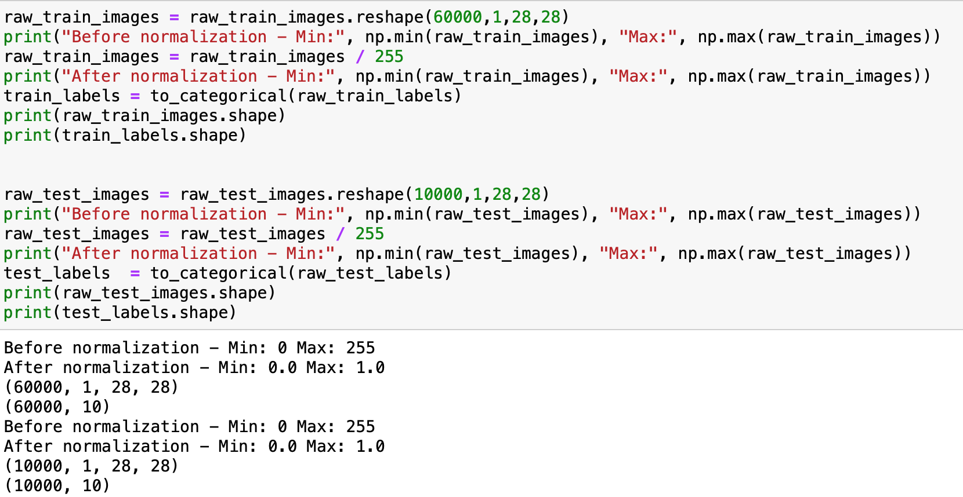

We are now ready to train our model. By training the model with the same number of iterations as before the time needed was really high (30min) so we decide to reduce the number of iterations at first. 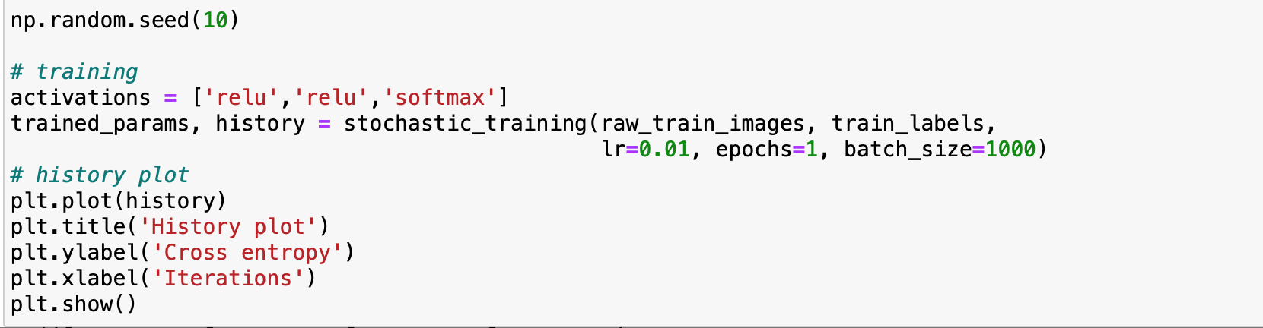

As a reminder the number of iterations is defined in the stochastic training function as the following :



Indeed we are going to have only 60 iterations in our case but at first hand it’s only to have a first approach of our model. Here is the Cross Entropy plot:

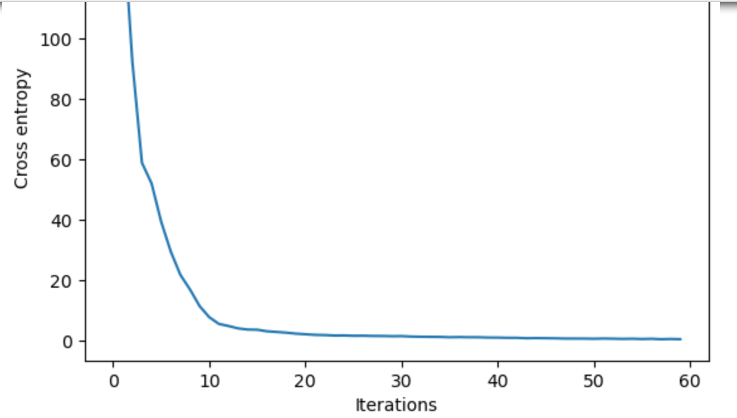

First of all the curve is decreasing and converging as we want. The accuracy that we obtain for the train set is :

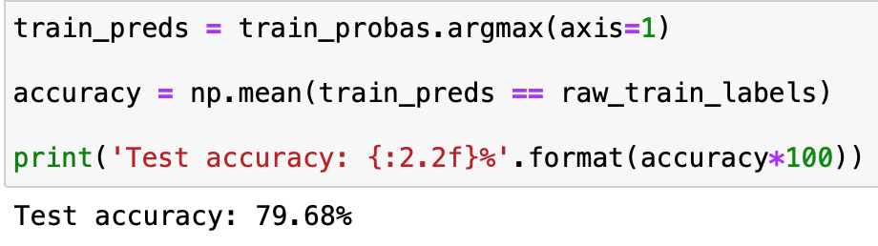(*train accuracy not test)

We get an accuracy of 79,68% on the train set which is not really satisfying but this might be due to the early stopping due to the low number of iterations.

We now use our model with the trained parameters that we obtained to do our prediction on the test set.

Concerning the test set the accuracy obtained is :

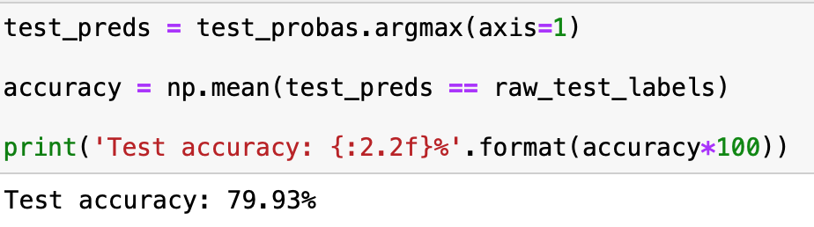

Even though the accuracy is not the highest as we want we can see that there is no overfitting.

**Digit Images :**

Finally we will use our model on the digit images as we did with the multilayer network. We just need to adapt the digit recognition function to our CNN model.

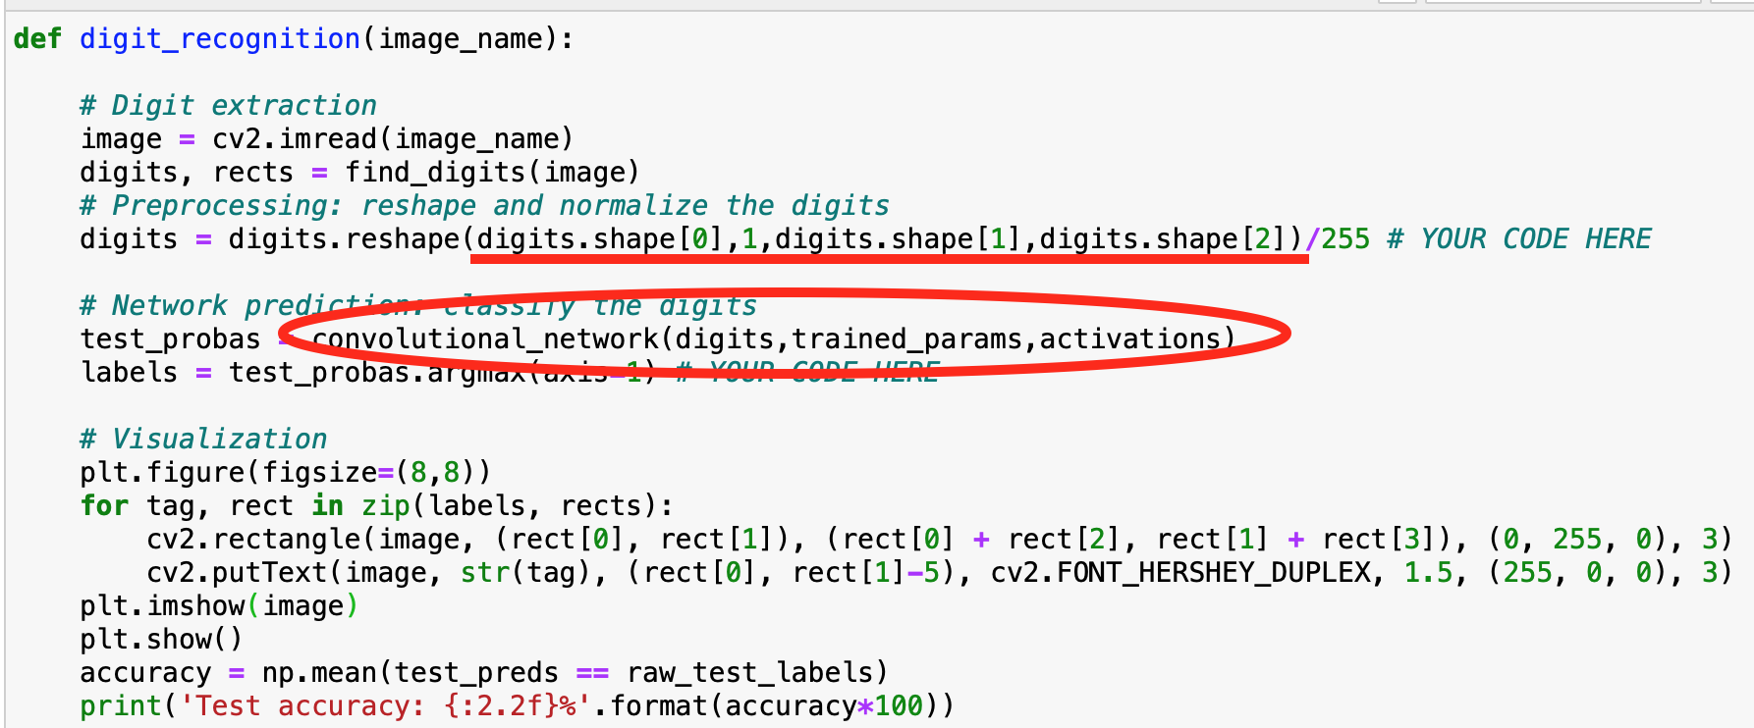

We need to modify the digits shape as 4D matrices to satisfy the input parameter shape of the convolutional network function. Moreover we need to use the convolutional network functon.

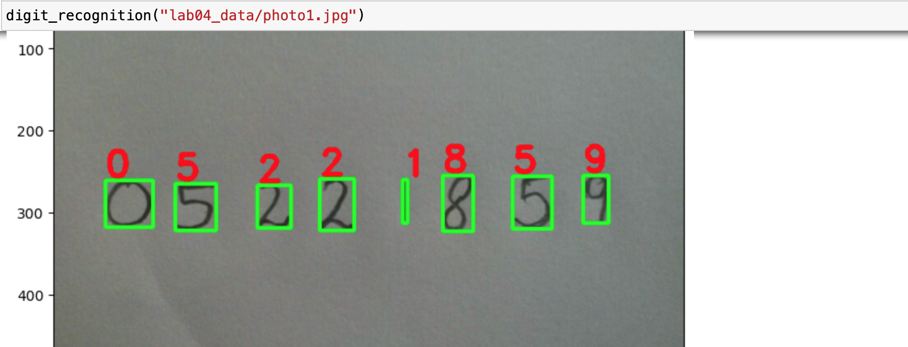

Even though we “only” have an accuracy of 79.93%, on this image and for this sample we are really accurate but this is not the case for the second images for which we can see that the accuracy of our model can be better :

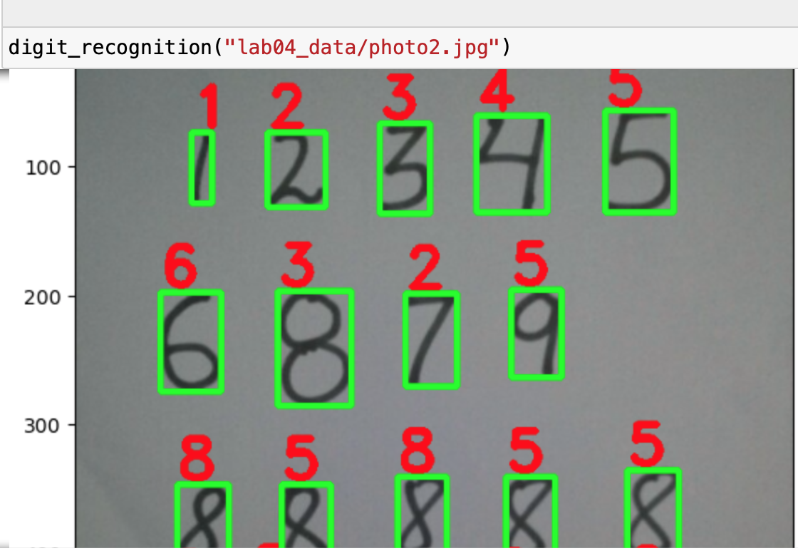

**Axes of amelioration :**

The first thing we can try to get a better accuracy for our model is to increase the number of iteration in the training part. We will try to double the number of iterations and see if the accuracy gain/time to train trade is satisfying :

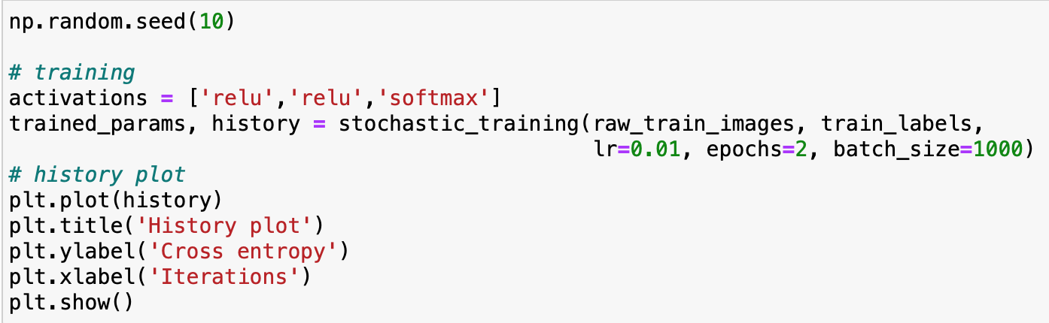

The history plot seems to be converging closer to 0 than with 60 iterations as we want :

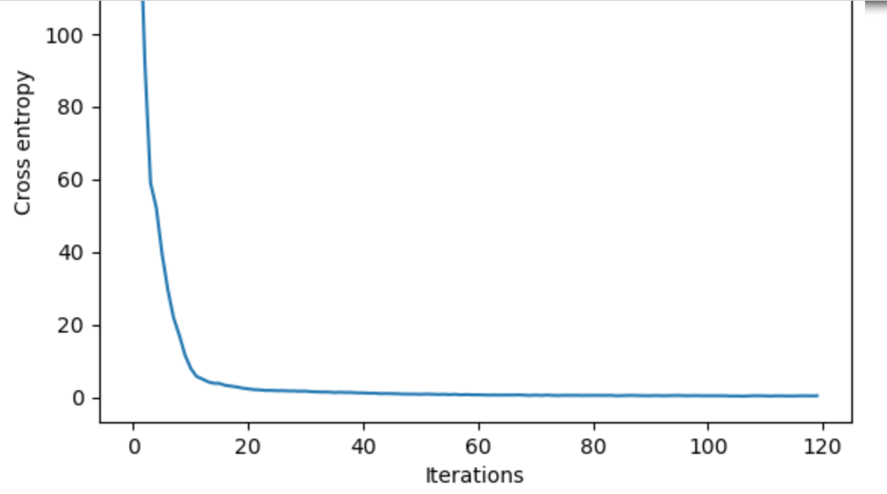

Here are accuracy on the training and testing sets :

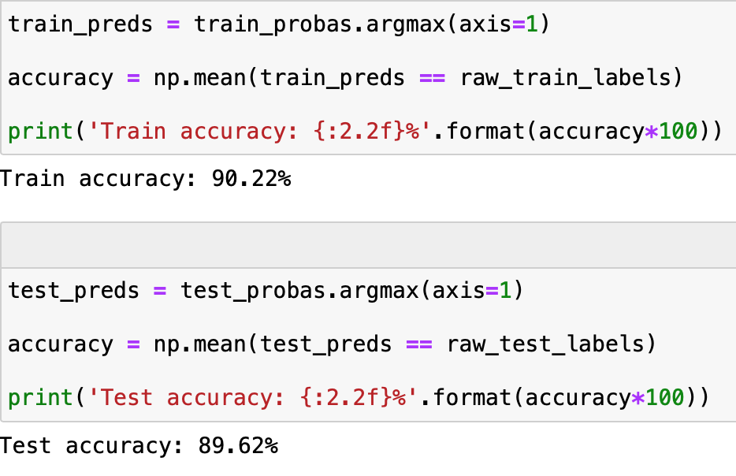

We gain 10% accuracy on the test set compare to the previous training with 60 iterations. Moreover the time to train just took few minutes (5 minutes / depending of the computer). We can say that this trade is satisfying.

Now checking if this increase in performance is showed on the prediction of the photo2 :

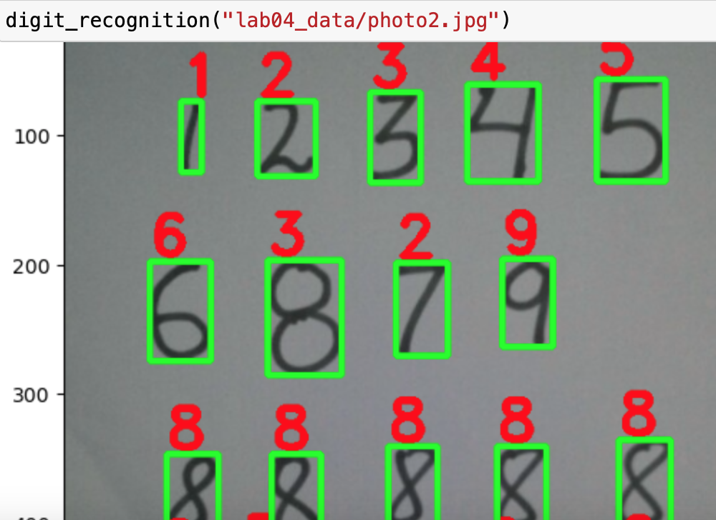

As expected with a better accuracy there is more chance to get a sample with less errors.

We now increase the number of iterations to 180 :

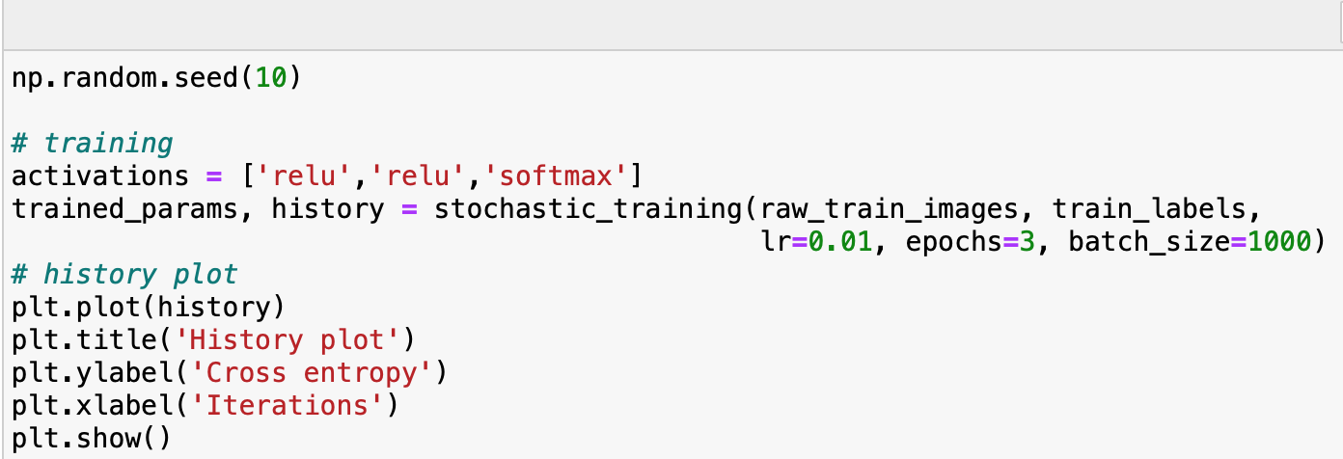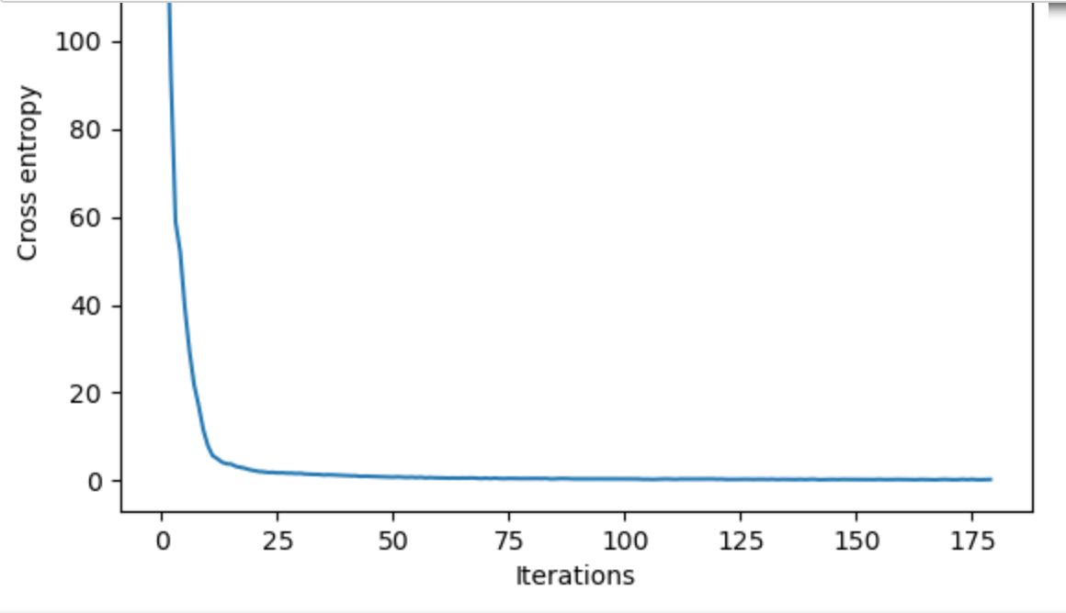

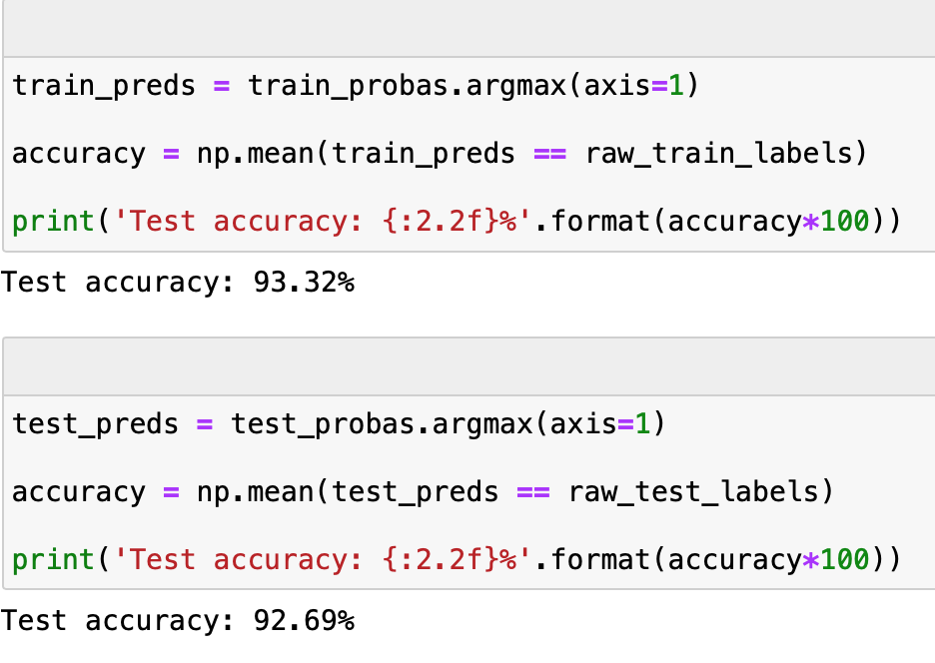(*train accuracy for the 93.32%)

First the accuracy on the test set is up to 92,69% which is really convincing. However the time to train the model was quite long (15min) that’s why the tradeoff is maybe not really worth. Hence because of the time needed to train we will keep the model with 120 iterations and with an accuracy of 89,62%. This increase of time is mainly caused by the time needed to do the convolution. Hence we can be satisfied by the accuracy of our model (89.62%) since it asked a lot less time and provide still a very good accuracy. In conclusion if we really want to get a better model as we saw it’s possible but we will need to wait more time.

**Conclusion :**

In conclusion this deep learning project take us on a journey from building a two layer neural network to building from scratch a multilayer neural network fully customizable and finally to a convolutional neural network. We trained our models and tried to achieve better accuracy by taking a look at alternative architectures. It made us familiar with the critical role of experimentation and parameter tuning. In the future we could try to use our models on different datasets. While the project has provided us a solid experimentation of what we learned during the course we are eager to learn more about this field.